Section 508 Compliance Test Report
Department of Homeland Security (DHS)
National Protection And Programs Directorate

Product Review Information
Requestor Agency: ICE | Review Date: 9/22/2017
Application Name: PostgreSQL pg Admin
Application Version: 1.22.2
Vendor: Amazon
Test Result: Not Compliant
URL/Product Type: N/A | Test Process Used: Trusted Tester 4.0
Application Description: AWS RDS’ PostgreSQL database will be used to house the Capacity Management DataMart; holds system related data for capacity management. We build visualization dashboards and reports off of the data in the DataMart. The PostgreSQL database software is provided as a cloud-based service via AWS RDS.
Functions Tested: User Controls, Navigational functions and Interactive elements
Test Environment  Operating System: Windows 7  Browser: N/A (N/A)  Compatibility View: N/A | ACMS Ticket #: 17-04832  Trusted Tester(s): (3) Halimatou Diallo  Trusted Tester ID#: 300010  Tester Agency: HQ

Applicable Section 508 Standards
1194.21 (Software Applications and Operating Systems), 1194.22 (Web-based Intranet and Internet Information and Applications), 1194.31 (Functional performance)

Review History
DHS Test Step | Section 508 Standard | Test Results
1.1 Keyboard Access | 21(a), 21(c), 31(a), 31(b) | (9/22/2017) Review 1: NC
3.2 Color Contrast | 31(b) | (9/22/2017) Review 1: NC
8 SW: Built-in Accessibility Features | 21(g) | (9/22/2017) Review 1: NC

Disabilities Impacted
Due to the Section 508 compliance issues identified in this report, this product may impact people with the following disabilities: Blind, Low Vision, Mobility.

Comments
This application was tested according to DHS Section 508 Compliance Test Process for Applications. The test process is posted online at http://www.dhs.gov/compliance-test-processes. (In Word report, ** before a failure condition means it was part of version 2.8 of the DHS Test Process.)

Section 508 Compliance Test Report
DHS Test | Description | Results
1.1 Keyboard Access | 1194.21 (Software Applications and Operating Systems) a (Executing Function From Keyboard), c (Input Focus), 1194.31 (Functional performance) a (Blindness), b (Low vision) Baselines: B01, B02, B03, B04 | NC
Example 1 | A. **An interactive element or function cannot be accessed or activated by keyboard (21(a), B01)  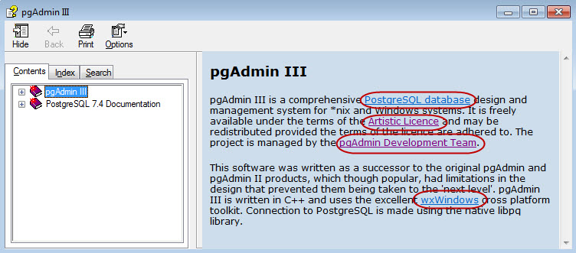  Within the Help, Contents screen, the links within the 'pgAdmin III' topic are not accessible to keyboard only users. This issue exists wherever split screen panes are used.  Location: Global | (9/22/2017) Review 1: NC
Example 2 | B. **A keyboard "trap" is found (21(a), B01)  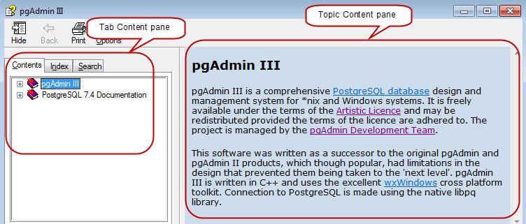  Within the Help screen, the user is unable to navigate between the split panes. For instance, the user is unable to navigate from the 'Contents' tab to the pane that contains the topic information and vice versa. In order to bypass the trap between the tabs (i.e., Content, Index and Search) and the pane containing the topic information, the user needs to use the mouse. This issue exists wherever split panes are used.  Location: Global | (9/22/2017) Review 1: NC
Example 3 | E. **At any time, there is no visual indication of the current focus (loss of focus) (21(c), B02)  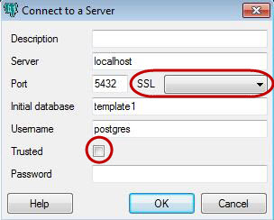  During keyboard navigation, the SSL pull-down menu and Trusted checkbox does not obtain visual focus.  Location: Connect to Server screen | (9/22/2017) Review 1: NC
Example 4 | H. The visual focus does not move to revealed content and no description of the content change is provided (31(a), 31(b), B04)  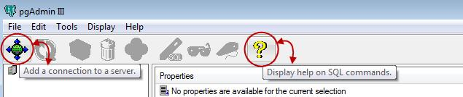  Reveal content associated with the connect to a server and help (i.e., Yellow question mark) buttons on the toolbar are not accessible to keyboard only users. Equivalent onscreen text or visual context does not exist for the user. This issue exist for most of the buttons residing on the toolbar.  Location: Global | (9/22/2017) Review 1: NC
Example 5 | I. The tab order is not logical (31(a), 31(b), B03)  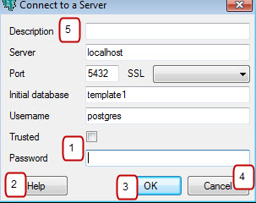  Within the 'Connect to a Server' dialog window, the tab order is illogical. For example, when the dialog window opens, the tab order starts at the Password field, then moves to the 'Help', 'OK' and 'Cancel' buttons, then up to the Description field at the top of screen, then proceeds to the rest of the input fields.  Location: Connect to a Server dialog window | (9/22/2017) Review 1: NC
3.2 Color Contrast | 1194.31 (Functional performance) b (Low vision) Baselines: B09 | NC
Example 1 | A. The contrast ratio is less than 4.5:1 for content background and foreground colors (31(b), B09)  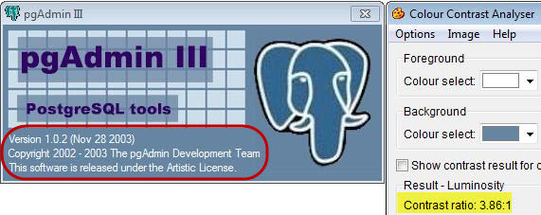  Text within the About dialog window have a color contrast ratio (3.86:1) that is less than 4.5:1. This issue exist wherever this color scheme is used.  Location: Global | (9/22/2017) Review 1: NC
Example 2 | A. The contrast ratio is less than 4.5:1 for content background and foreground colors (31(b), B09)  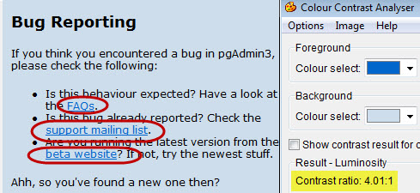  The interactive text within the Bug Reporting screen have a color contrast ratio (4.01:1) that is less than 4.5:1. This issue exist wherever this color scheme is used.  Location: Global | (9/22/2017) Review 1: NC
Example 3 | A. The contrast ratio is less than 4.5:1 for content background and foreground colors (31(b), B09)  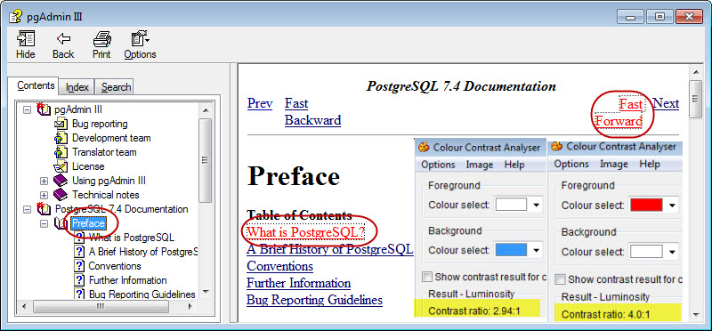  From the Help menu, within the 'Contents' screen, the below text items have color contrast ratios that are below 4.5:1 when focused. This issue exists wherever this color scheme is used.  - 'Preface' (2.94:1)  - 'What is PostgreSQL?' and 'Fast Forward' (4.0:1)  Location: Global | (9/22/2017) Review 1: NC
8 SW: Built-in Accessibility Features | 1194.21 (Software Applications and Operating Systems) b1 (Accessibility Features), g (User Selected Attributes), j (Color Contrast Settings), 1194.31 (Functional performance) c (Deafness), f (Mobility) Baselines: B28 | NC
Example 1 | C. Text of application did not enlarge or became illegible when enlarged (21(g), B28)  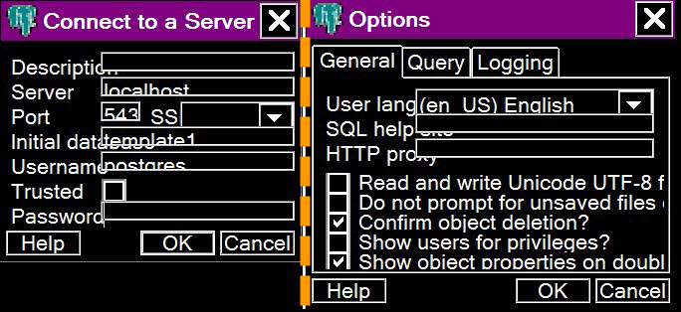  As a result of the OS text size settings, the input fields within some of the dialog windows were not in alignment with their associated onscreen label and the pre-populated text in some input fields are partially displayed.  Location: Connect to a Server and Options dialog windows | (9/22/2017) Review 1: NC

Note: This review is a sampling of pages to confirm the agency self-assessment as to their compliance with Section 508. The responsibility for full and complete testing and compliance remains with the owner of the application or website.

DHS Specific Test Approaches

DHS specific test approach for Flashing (Baseline 10 and Section 508 [21k and 22j])

The term 'flickering' encompasses interface elements that flash, blink, flicker repetitively, or elements that scroll (e.g., marquee text).
Current Section 508 requirements do not permit elements to flash or flicker at frequencies between 2Hz and 55Hz. To incorporate the expected update to this requirement, this flashing test adopts the WCAG 2.0 frequency restriction to below 3Hz.
Due to factors that are not within the developer's control (such as the refresh frequency of a user's monitor, Internet speed, and other display factors), the frequency of a flashing item can be unpredictable from computer to computer. Given this uncertainty, the only specification that can be inspected is the programmed frequency of flashing items. Flashing elements that do not have a frequency property or attribute will be found not compliant.
How To Test
1. Visually check for any flashing or blinking interface elements or scrolling text. Scrolling images should be tested under Section 2.2 (SW animation) or Section 2.4 (video).
2. Determine if the flickering element is Software or Web.
3. Determine the programmatic frequency of the flickering element. This will often require viewing source code and/or contacting the developer.
To view the source of a part of the page, highlight the section of the page using the mouse. Use WAT>Doc Info>View Partial Source.

DHS specific test approach for Variety of Color Selections in SW (Section 508 21j)
If an application adopted the OS high contrast colors, 21(g) and 21(j) are compliant per Baseline 28. If the application did not adopt the OS high contrast colors, 21(g) is not compliant. However, if the application offers its own color options, then 21(j) can be compliant.

Section 508 Test Results

21(a) | Executing Function From Keyboard | NC
21(b) | Accessibility Features | C
21(c) | Input Focus | NC
21(d) | Interface Elements | C
21(e) | Bitmap Images | C
21(f) | Textual Information | C
21(g) | User Selected Attributes | NC
21(h) | Animation | DNA
21(i) | Color Coding | DNA
21(j) | Color Contrast Settings | C
21(k) | Flashing or Blinking Text | DNA
21(l) | Electronic Forms | C
22(a) | Text Equivalents | DNA
22(b) | Multimedia: Captioning | DNA
22(c) | Color Dependence | DNA
22(d) | Style Sheet Dependence | DNA
22(e) | Server Side Image Map Text Links | DNA
22(f) | Use Client Side Image Maps | DNA
22(g) | Data Table Headers | DNA
22(h) | Complex Data Table Header-Cell Association | DNA
22(i) | Frame Titles | DNA
22(j) | Flicker | DNA
22(k) | Text-only Alternative | DNA
22(l) | Script Functional Text | DNA
22(m) | Plug-In Links | DNA
22(n) | Form Labels | DNA
22(o) | Skip Navigation | DNA
22(p) | Timed Response | DNA
24(c) | Captioned | DNA
24(d) | Audio Described | DNA
31(a) | Blindness | NC
31(b) | Low vision | NC
31(d) | Hard of hearing | DNA

(C=Compliant, NC=Not Compliant, DNA=Does Not Apply)

Baseline Test Results

B01 | Keyboard navigation | NC
B02 | Focus (visible) | NC
B03 | Focus (order) | NC
B04 | Focus (Revealing hidden content) | NC
B05 | Skip-navigation links | DNA
B06 | Multi-state components | C
B07 | Images | C
B08 | Color (meaning) | DNA
B09 | Color (contrast) | NC
B10 | Flashing (reserved)* | DNA
B11 | Forms (associated instructions) | C
B12 | Page Titles | C
B13 | Data Tables (headers) | DNA
B14 | Data Tables (cell-header mapping) | DNA
B15 | Headings | DNA
B16 | Links and user controls | C
B17 | Language | DNA
B18 | Audio (transcripts) | DNA
B19 | Video (descriptions) | DNA
B20 | Synchronized Media (captions) | DNA
B21 | Synchronized Media (descriptions) | DNA
B22 | Style-sheet non-dependence | DNA
B23 | Frames | DNA
B24 | Alternate pages | DNA
B25 | Time outs | DNA
B26 | Image maps | DNA
B27 | Plug-in Links | DNA
B28 | Built-in accessibility features | NC

(C=Compliant, NC=Not Compliant, DNA=Does Not Apply)

