PostgreSQL 10.7 on x86_64-pc-linux-gnu, compiled by gcc (GCC) 4.9.3, 64-bit
Aurora version : 2.3.5

1. From Master User - SELECT rolname, has_schema_privilege(rolname, 'public', 'usage') from pg_roles;

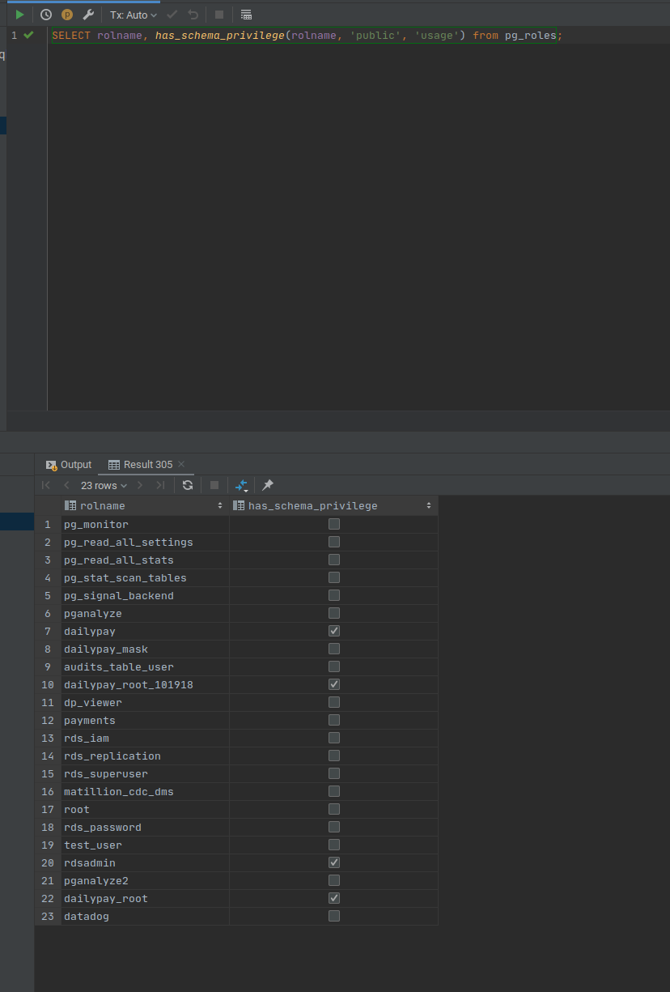

2. From Master User - create user new_user2 password '****';

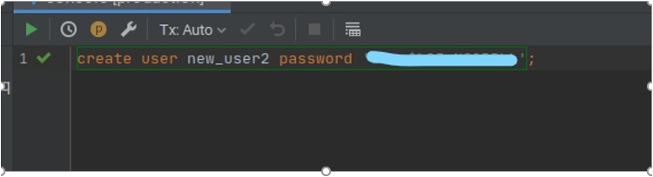

3. From Master User - SELECT rolname, has_schema_privilege(rolname, 'public', 'usage') from pg_roles;
User name: new_user2

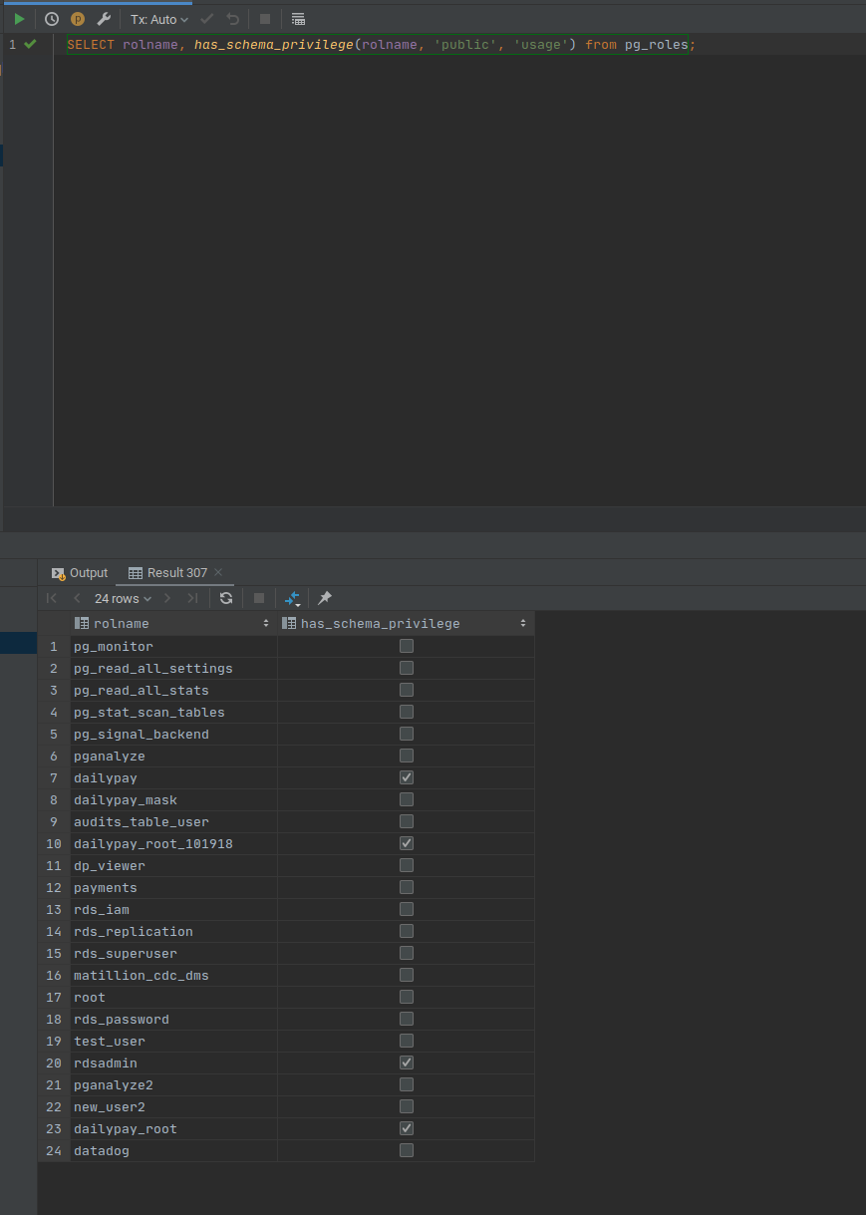
4. From Master User - GRANT ALL PRIVILEGES ON SCHEMA public TO GROUP new_user2;
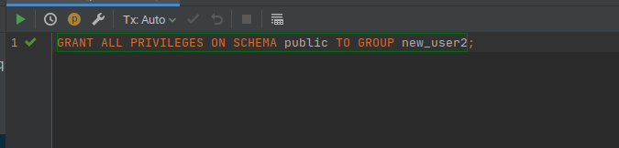

5. From Master User - \c <db_name> new_user2
6. From new_user2 user - create table public.tab3(id int);

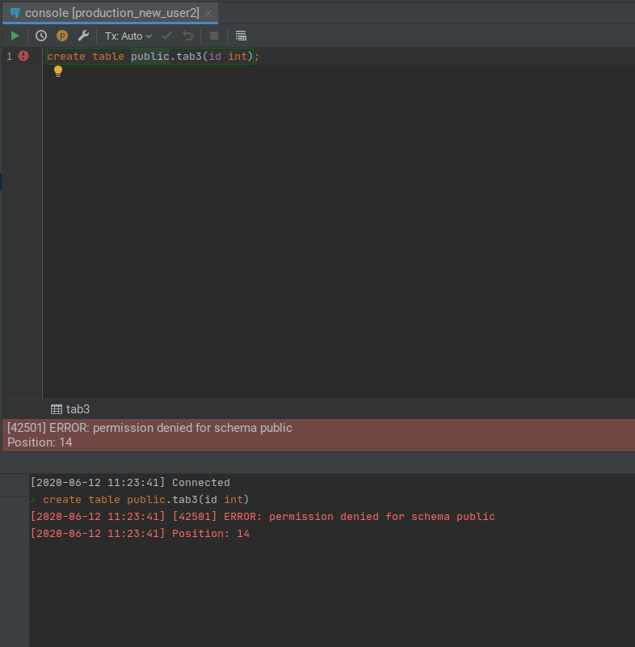

7. Output of below from Master User - SELECT n.nspname as "Schema",
c.relname as "Name",
CASE c.relkind WHEN 'r' THEN 'table' WHEN 'v' THEN 'view' WHEN 'm' THEN 'materialized view' WHEN 'i' THEN 'index' WHEN 'S' THEN 'sequence' WHEN 's' THEN 'special' WHEN 'f' THEN 'foreign table' WHEN 'p' THEN 'table' END as "Type",
pg_catalog.pg_get_userbyid(c.relowner) as "Owner"
FROM pg_catalog.pg_class c
LEFT JOIN pg_catalog.pg_namespace n ON n.oid = c.relnamespace
WHERE c.relkind IN ('r','p','')
AND n.nspname <> 'pg_catalog'
AND n.nspname <> 'information_schema'
AND n.nspname !~ '^pg_toast'
AND pg_catalog.pg_table_is_visible(c.oid)
ORDER BY 1,2;

8. du+

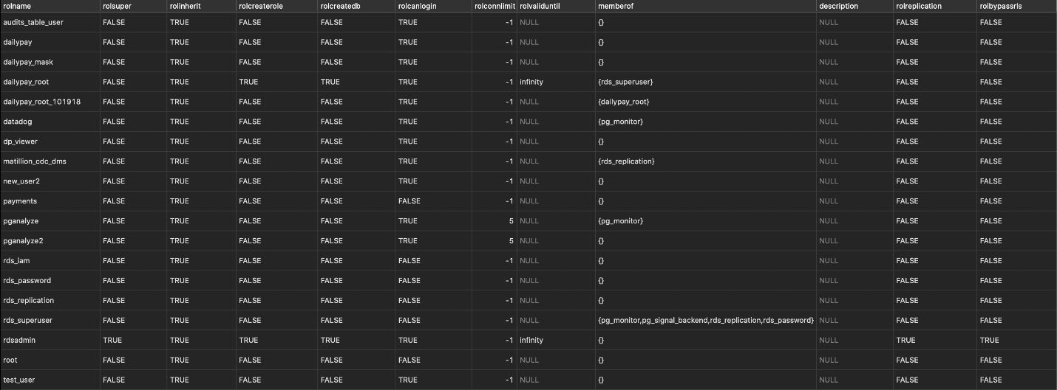

9. From Master User - SELECT coalesce(nullif(role.name,''), 'PUBLIC') AS name,nspname,
substring(
CASE WHEN position('U' in split_part(split_part((','||array_to_string(nspacl,',')), ','||role.name||'=',2 ) ,'/',1)) > 0 THEN ', USAGE' ELSE '' END
|| CASE WHEN position('C' in split_part(split_part((','||array_to_string(nspacl,',')), ','||role.name||'=',2 ) ,'/',1)) > 0 THEN ', CREATE' ELSE '' END
, 3,10000) AS privileges
FROM pg_namespace pn, (SELECT pg_roles.rolname AS name
FROM pg_roles UNION ALL SELECT '' AS name) AS role
WHERE (','||array_to_string(nspacl,',')) LIKE '%,'||role.name||'=%'
AND nspowner > 1;

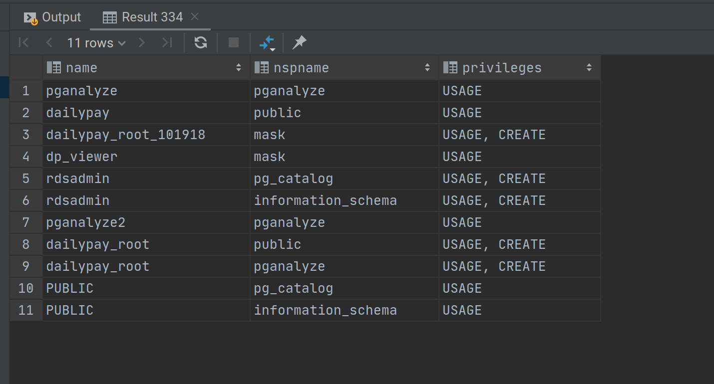

Additional test: Granted create database to user and it reflects for new_user2.
