URL Guideline – What makes a URL, a “right” URL?

During the collaboration with our partner, Microsoft often asks the partner for the “URL” so that we can navigate our end users to the exact page that the partner wants end users to land. This is very important URL, not just any URL but it has to be the “right” URL. So, what makes the URL a “right” URL? We wanted to provide you with the guideline on the URL that our mutual end users will continue being satisfied end users.

## Why URL is needed?

The URL we get from you will be used in the dialogue shown when the end users face with certain types of compatibility issues with their applications or drivers. When end users face with the known compatibility issues, we want to help them to get to right information or solution immediately and seamlessly, so that end users can go back to the tasks they were trying to accomplish. We want end users to click the below “Check for solutions online” (this is sample dialogue message) that take them to exact page that explains the issue they’ve experienced, and provide solution instantly.

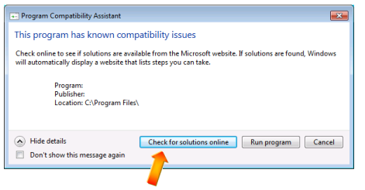

We don’t want them navigating many pages to find solution, or keyword searching webpage for articles that talk about the symptoms. Compatibility issue that end user is facing, can turn into great satisfying opportunity to have them update their software, if we provide the right destination. Also this URL information will be listed in the XML database which is part of Windows, which makes it hard to change frequently once it’s deployed. **If it is difficult for you to come up with the fully specified URL at the time of our URL request, Redirect URL/tiny URL/FWLink is sufficient**.

## What makes the URL a “right” URL?

When you receive the URL request during the collaboration with Microsoft on issue mitigation, please review following questions to make sure that URL you’re going to create and provide Microsoft, would have the “Yes” answer to all.

* Is the landing page straightforward and uncomplicated? Can you link to a better page? (The number one reason we clarify responses is that it links to a top-level page, like [www.microsoft.com](http://www.microsoft.com), which is not specific enough to the end users)
* In case if you are providing solutions such as patch files, is solution within the easy reach of the user? The ideal links are within three clicks away from the main URL in dialogue itself
* Is your download as directly and easily usable as it could possibly be? Users have an easier time with an MSI than they do with a self-extractor or .zip file, for example. And the smaller the download, the better.
* If you are just providing the workaround to the issue, is the explanation clear enough for end users to proceed?

## Resources:

When creating the WER Response, we ask for our partners to use the “right” URL as well. This is the article specifically about WER response URL, but our guideline is the same.

A checklist to help you create clear and accurate responses  
<http://blogs.msdn.com/b/wer/archive/2010/11/09/a-checklist-to-help-you-create-clear-and-accurate-responses.aspx>

End of document